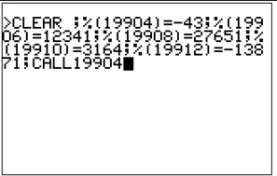Well, we sort of have it running MINOL. Very shoddily, but it does work, and as defined by the document from DDJ.

Admittedly you do have to type it into the assembler directly , well, with a macro anyway – but it does sort of work and seem to do what it’s supposed to.

1 "START:CLEAR:INA:PR A,A,A,A:GOTO240

10 HELLO WORLD

20 GOTO 20

30 LETB=69:LETA=42:C=A+B:END

120 D=D+1:(0,4)=D:(12,130)=69:GOTO120

130 A=!:B='@':C=42:D=0-1:GOTO130

140 IF1#255;A=A+1:B=B+1

150 IF255#255;C=C+1:D=D+1

200 LETA=0

210 LETA=A+1:IFA#250;GOTO210

240 PR42,69,Y

241 PR "A:",A,"STAR TREK"

242 PR "(",$(144,33),")"

Next up, the console stuff – editing programs, running commands from the keyboard and so on.